SEBAHODNOTENIE
trieda: 2.A

Meno a priezvisko: ___________________________

Ako čítam? _______________________________________________________________________________________________________________________________________

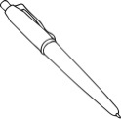 Ako píšem? _______________________________________________________________________________________________________________________________________

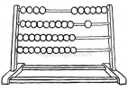 Ako počítam? _______________________________________________________________________________________________________________________________________

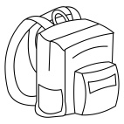Ako som pracoval/-a v 2. ročníku? ____________________________________________________________________________________________________________________________________________________________________________________

